Materials:

Soldering iron

Plastic Bottle

Water Hose

Procedure:

1. Use the soldering iron to create a perfect size hole for the hose to enter at the cover of the water bottle.

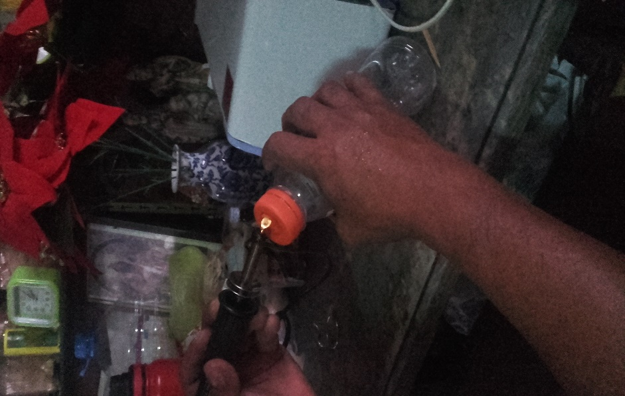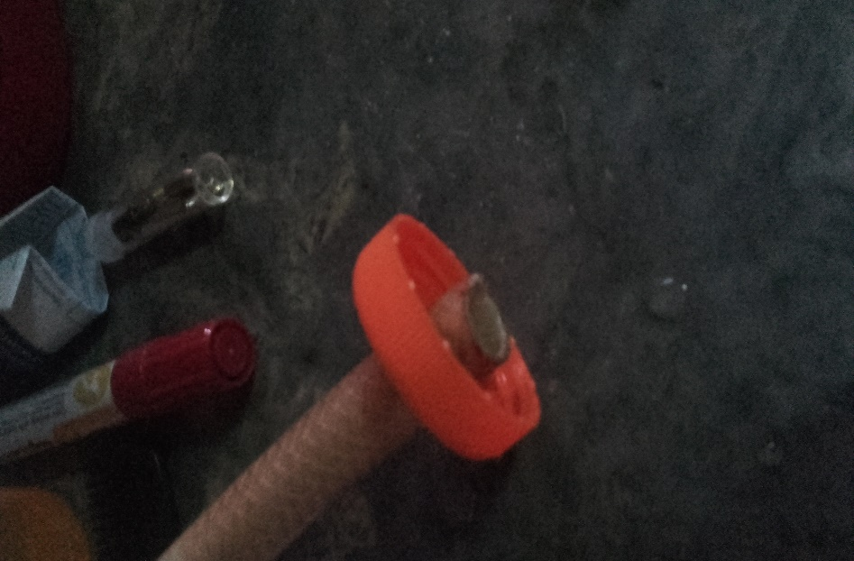

1. 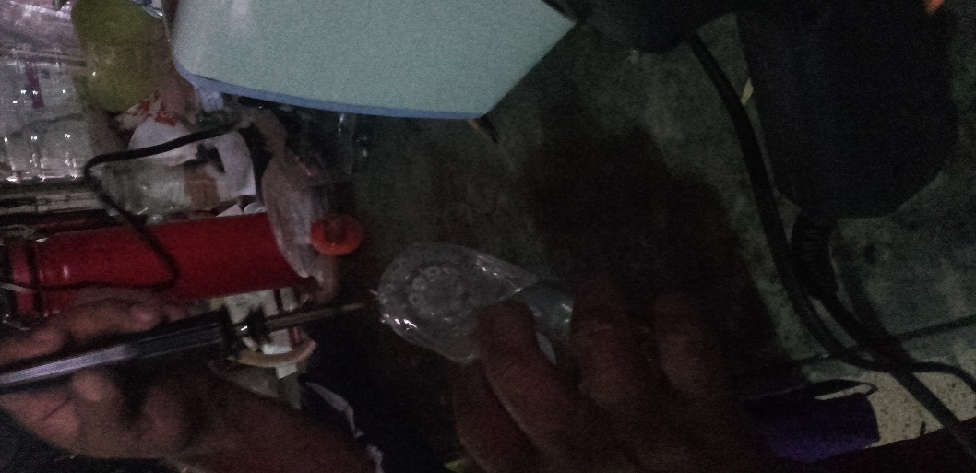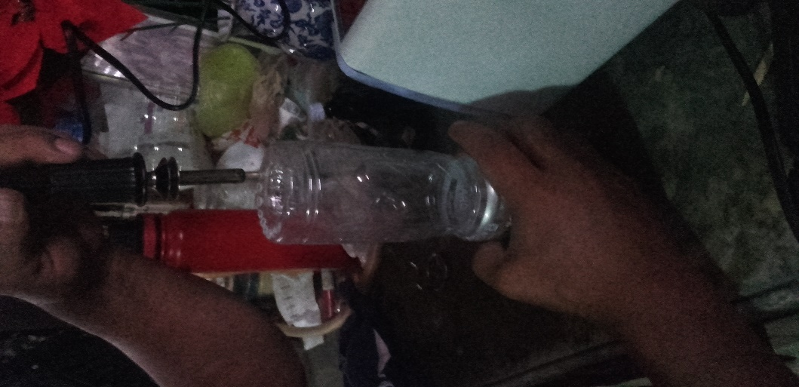Use the soldering iron to create small holes at the bottom of the water bottle for exit of the water bottle. Congratulations you’ve now made a water bottle sprinkler.